**Protocol Design**

When starting up a server, the server will be always standby waiting for the clients to login.

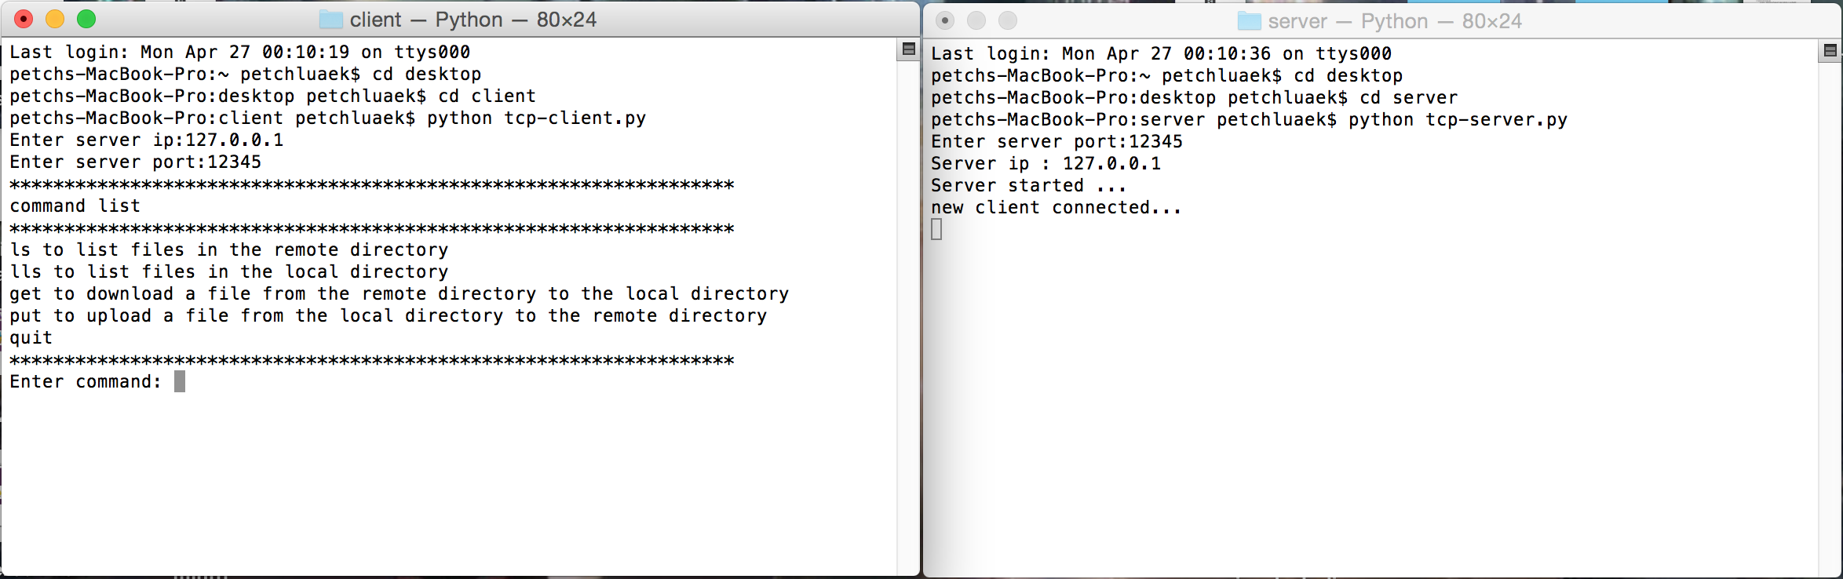

ls (or dir) – list files in the remote of directory (server) according to the path added after the command.

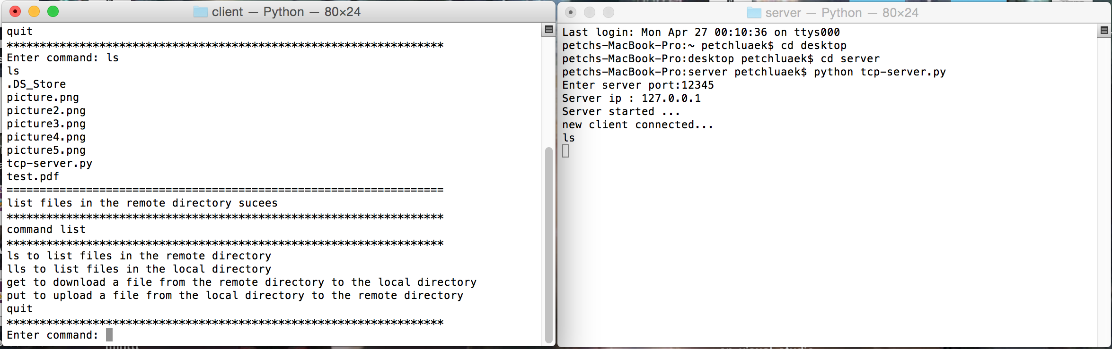

List files

ls

Client

Server

ls

put – upload the file from the client to server

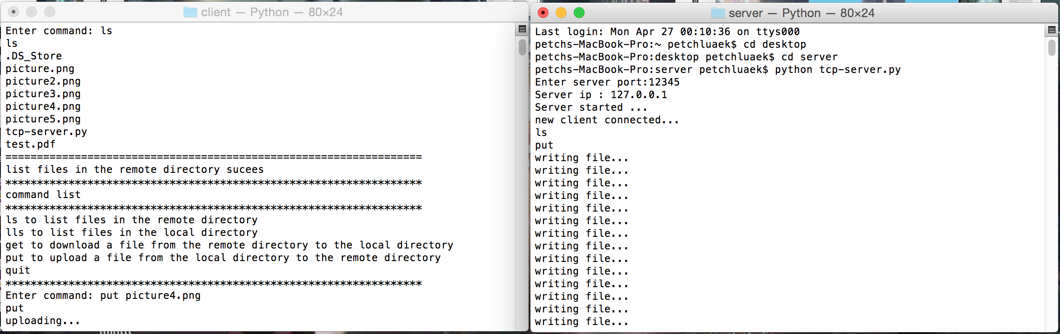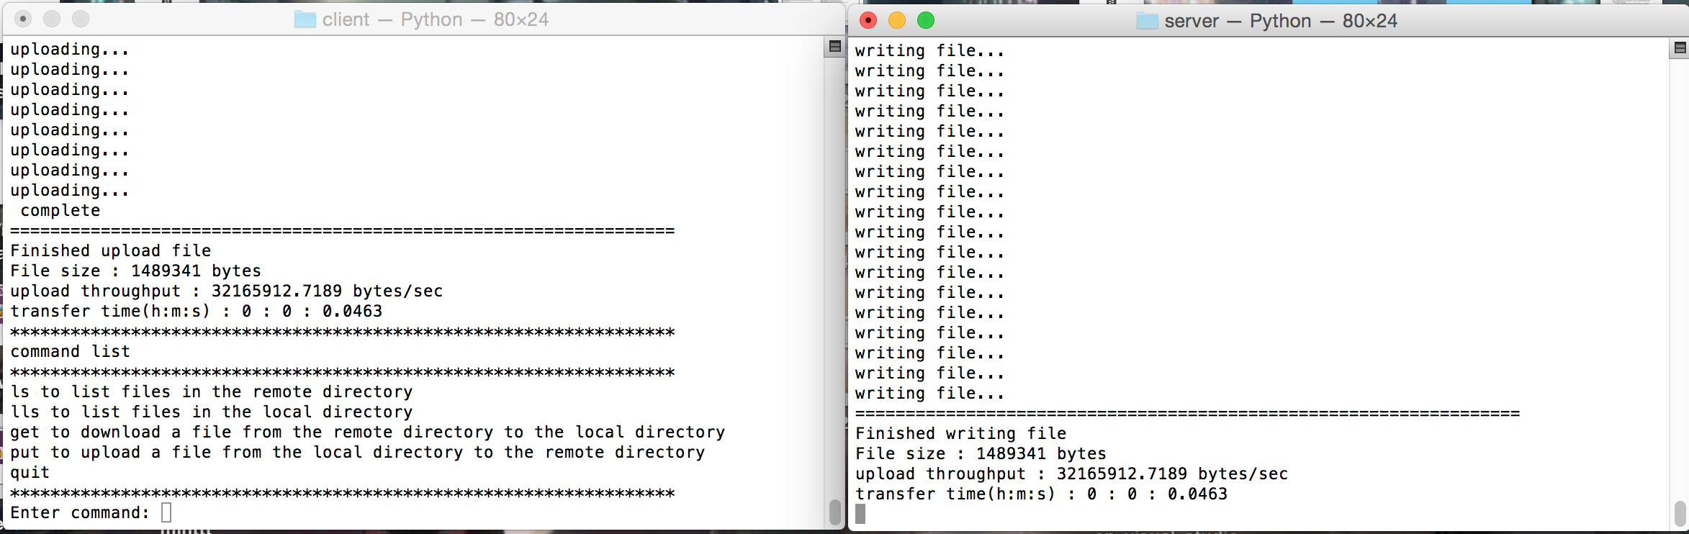

Write file (wb)

Calculate time

Content+filesize

Start timer

Get file (rb

Get file size

put

Client

Server

get – download the file from the server to client).

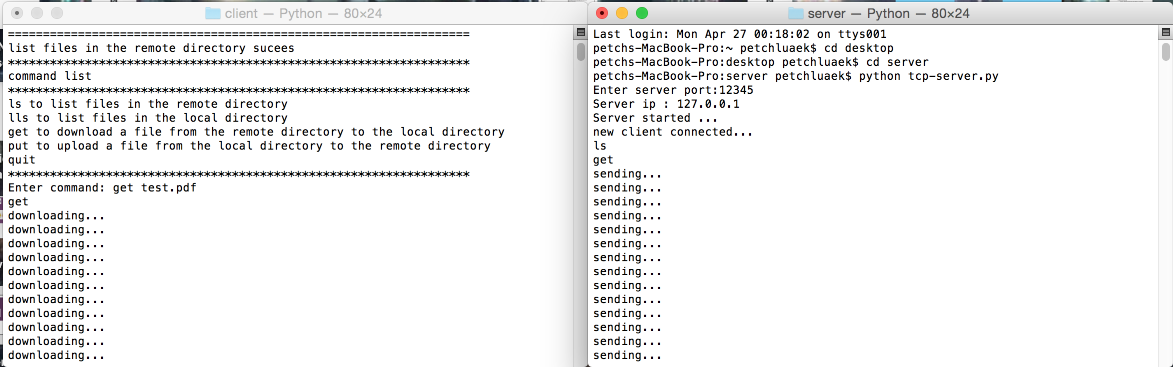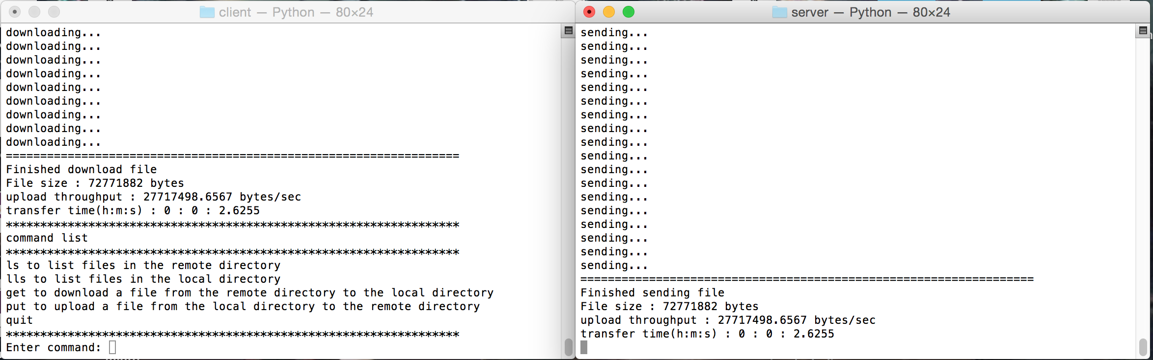

Write file (wb)

Calculate time

Content+filesize

Get file (fb)

Get file size

Start timer

get

Client

Server

lls (or ldir) – list files in the local directory according to the path added after the command.

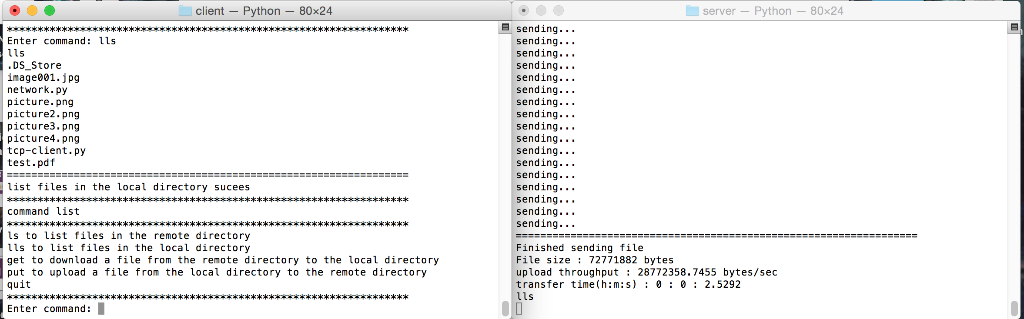

List files

lls

Client

Server

quit - disconnect from the server.

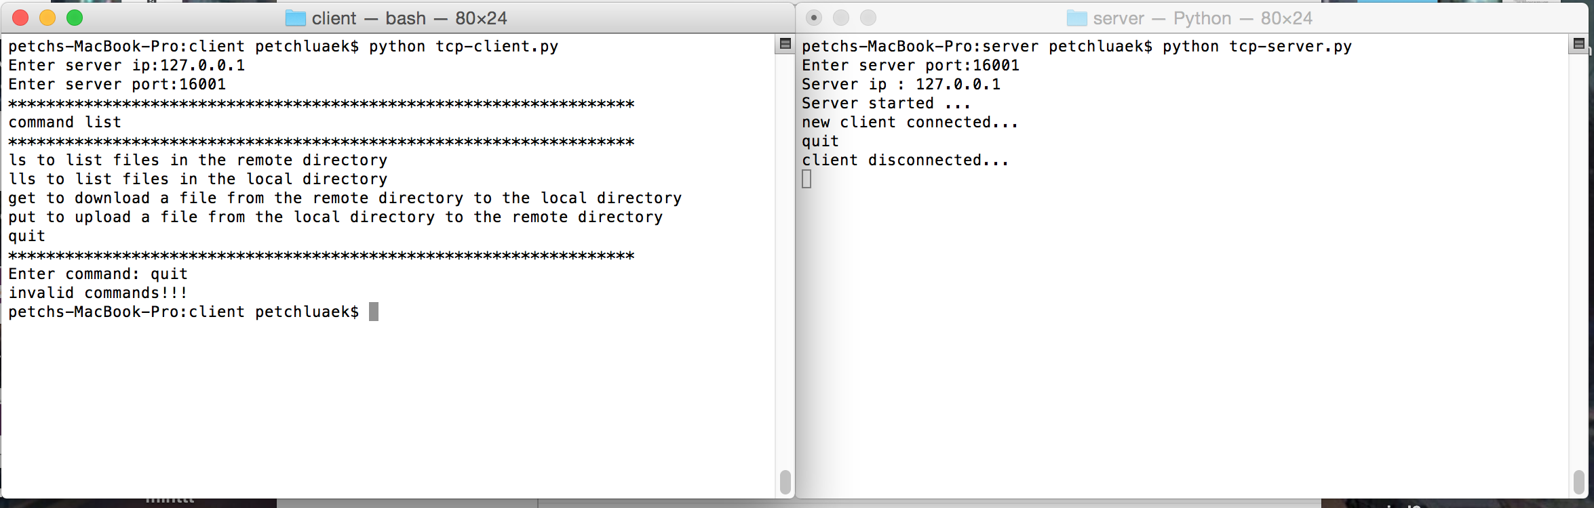

If wrong syntax it will show an error.

Like this

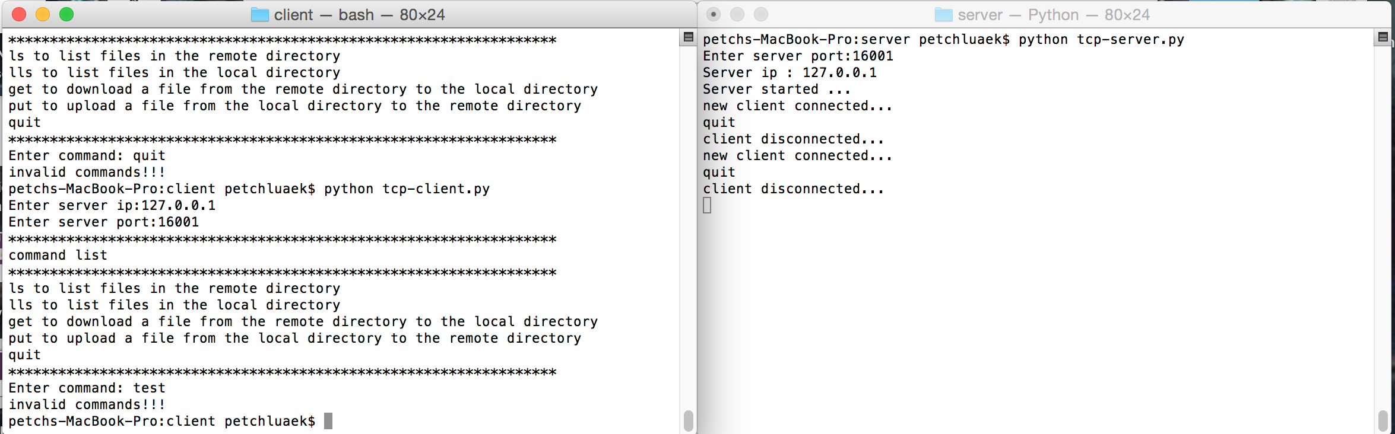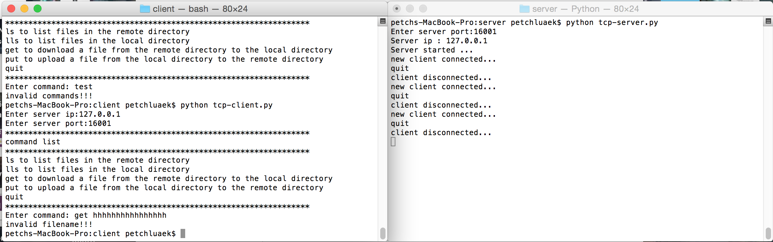

Member

Jatenipat Nawakitrangsan 55070503406

Wasu Jinajin 55070503440

Petch luaek 55070503465

Wanaporn Suesat 55070503438